

The Metreos Application Suite
Customizable IP Telephony Applications for Business

Release 1.0

User Guide

Copyright © 2004 Metreos Corporation
All Rights Reserved

Table of Contents

Preface 3
Who should read this guide? 3
The Metreos Application Suite 4
Applications in the Suite 4
Application Suite Login and Configuration 6
Metreos VoiceTunnel 7
VoiceTunnel Error Conditions 8
Metreos ClickToTalk 11
Metreos ActiveRelay 14
Metreos ScheduledConference 15
Metreos Intercom 17
Metreos RapidRecord 18
Preface
No part of this publication may be reproduced, stored in a retrieval system, or transmitted in any form by any means, without written permission from the publisher.

Metreos Corporation makes no representations that the use of its products in the manner described herein will not infringe upon existing or future patent rights, not do the descriptions contained in this publication imply the granting of licenses to make, use, or sell equipment or software in accordance with the description.

Possession, use, or copying of the software described in this publication is authorized only pursuant to a valid written license from Metreos or an authorized sublicensor.

Neither Metreos Corporation not its employees are responsible for any errors that may appear in this publication. The information in this publication is subject to change without notice.

The following are trademarks of Metreos Corporation: Metreos, Metreos Application Suite, Metreos Visual Designer, and the Metreos logo. All other trademarks and service marks are the property of their respective holders.

Who should read this guide?

This document describes the usage of each of the IP telephony applications in the Metreos Application Suite™, and as such is targeted to the users of those applications. For Application Suite configuration instructions, the administrator should refer to the Metreos Application Suite Administration Guide.
The Metreos Application Suite
The Metreos Application Suite™ is a collection of the most in-demand voice over IP applications for the enterprise. Each application in the suite is a complete IP telephony application, ready to deploy and run at your site. Since each application is built using Metreos visual tools and executes within the Metreos runtime environment, each is easily and quickly customizable by your staff or integrator, should you wish to do so.

Applications in the Suite
The Metreos Application Suite includes the following IP telephony business applications. The presence of any individual application in your deployment is dependent upon the license in effect.

Metreos VoiceTunnel
Metreos VoiceTunnel™ allows a remote user to connect to any enterprise IP communications system and place calls as if they were local to the system. With Metreos VoiceTunnel, the enterprise can:
- Place all calls locally, avoiding international and long-distance toll charges.
- Authenticate call usage and apply a broad range of policies to the billing and accounting of communications costs.
- Manage, monitor, and report on usage of the communications system.

Metreos ClickToTalk
Metreos ClickToTalk™ is a speed dialing application permitting the calling of any party in a contact list with a single click. ClickToTalk can be used by anyone in a Cisco CallManager group using a Cisco 7940, 7960, or 7970 IP telephone. A ClickToTalk user might select an entry from his or her Microsoft Outlook contact list, click a button on the Outlook UI, and ClickToTalk will dial that contact from the user’s IP phone. Conferencing and recording of calls are also supported.

Metreos ActiveRelay
Metreos ActiveRelay™ permits the placing of calls to any individual using a single number, wherever that individual might physically be located. Metreos ActiveRelay bridges your cellular telephone to your office telephone and rings both simultaneously, allowing you to choose which to answer. Once connected, the call can easily be transferred to other devices configured with ActiveRelay. To the caller, the call sounds like a normal call, and does not exhibit the multiple ring sequences common to older style phone applications in this genre.

Metreos ScheduledConference
Metreos ScheduledConference™ is a Web-scheduled dial-in and dial-out conferencing system. Conferences can be scheduled from an easy-to-use web interface eliminating the need for costly operator or administrative assistance when setting up conference calls. Features include the adding of conference parties, party mute and unmute, and removal of participants from conference.

Metreos Intercom
Metreos Intercom™ permits instant communication over IP phones without the need to dial a number. Lifting the handset, a user selects from a menu the parties to whom they wish to communicate, and audio connectivity is instantly established. Metreos Intercom can be configured to act as a group paging system for the broadcast of voice messages or pages, in the manner of a traditional paging system. Using the TalkBack feature, an intercom listener can press the Reply button and conference instantly with each party in the intercom group.

Metreos RapidRecord
Metreos RapidRecord™ automatically records calls placed to and from a configured group of frontline devices, permitting seamless, hands-off call recording. Calls so recorded may be played back either from a Web interface, or directly from the IP phone that placed or received the call. Since all calls are recorded, businesses can avoid the problem common to other applications in this genre, that of missing call content occurring prior to the time recording could be enabled.
.

Application Suite Login and Configuration

Before You Begin
Since each application in the Metreos Application Suite runs in the context of the Metreos runtime environment, the administrator should ensure that the Metreos runtime environment is active.

Logging In
Some applications in the suite require configuration via the Metreos Application Suite Administration Console. For example, to schedule a conference using the ScheduledConference application, you will log into the administration console and schedule your conference from the Metreos ScheduledConference page.

After navigating to the administration URL, http://yourserver/appsuiteadmin, you are presented with a login page. Your administrator will have supplied you with an initial user name and password with which to obtain access to the administration console. Enter your user name and password on this page.

Once logged in, you can access all Metreos application configuration options from the main configuration page, as shown in Figure 1 below.

Figure 1: Application Suite Administration Home
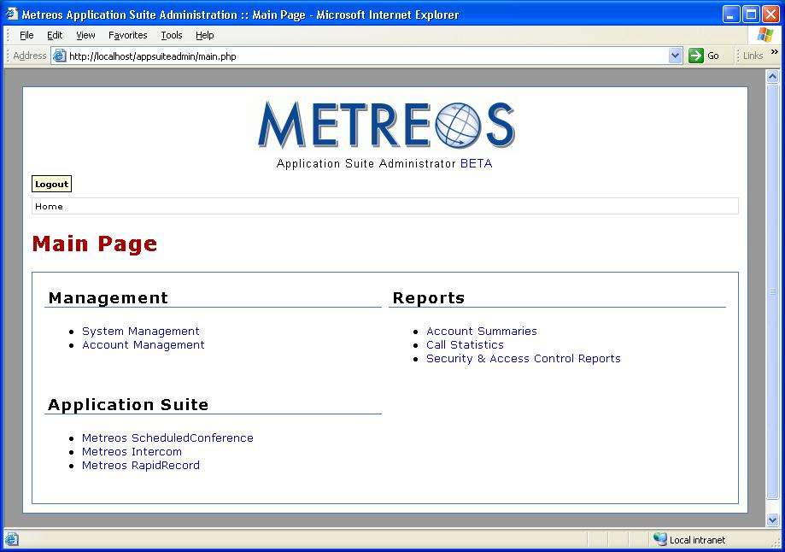
Metreos VoiceTunnel

Metreos VoiceTunnel™ provides the means for calls to be placed over an IP link between remote sites. By dialing into Metreos VoiceTunnel, a caller can avoid long-distance charges which might otherwise be incurred had the call been routed over the IP network. VoiceTunnel routes the call to the remote site best able to handle the call, from where it is routed back to the PSTN as a local call.

Using VoiceTunnel
The simple steps involved in using VoiceTunnel to place a call are:
- Log into VoiceTunnel.
- Enter billing codes, if any.
- Enter the number to dial.

Logging In
To begin using VoiceTunnel, simply call the VoiceTunnel number configured by the VoiceTunnel administrator. You will hear a greeting and will be asked for your VoiceTunnel account number. Enter the account number with which you wish to have this call associated, followed by the pound (#) key.

Next you will be asked for a Personal Identification Number (PIN). Enter the PIN associated with the account number you entered previously. Account and PIN numbers will have been supplied to you by the VoiceTunnel administrator.

Billing Codes
Once logged in, you may be asked for a project code, if VoiceTunnel has been so configured at your installation.

Project Code
If you are indeed prompted for a project code, a list of valid project codes will have been provided you by the VoiceTunnel administrator. Project codes are VoiceTunnel’s means of associating a call with a project, for purposes such as billing. Enter the project code for your call, followed by the pound (#) key.

Client Code
Next you may be asked to enter a client code. The client code is VoiceTunnel’s means of associating a call with a called party. Since a given party may be contacted at several different telephone numbers, the destination number obviously would not be the best way to maintain this association. The VoiceTunnel administrator will have provided you a list of client codes valid for each project code. Enter the client code for your call, followed by the pound (#) key.

Calling Your Party
After logging in and entering any requested accounting information as described above, you will be asked to enter the number you wish to dial. VoiceTunnel is configurable by the administrator to apply dialing rules to the number you enter, so unless instructed otherwise, you should enter the number as you normally would from your office phone, followed by the pound (#) key.

You will hear an announcement confirming that your call is being connected, at which point VoiceTunnel will be identifying the optimal remote gateway to use to connect the call. Once connected, you may talk as usual.

Ending a Call
At any point during a VoiceTunnel call you may either hang up, or key in triple-pound (###) to indicate that you wish to end the call and begin another using your current login and accounting information.

VoiceTunnel Error Conditions
This section presents the various error conditions which could occur during a VoiceTunnel session, along with possible causes and resolutions for each. In many cases, an administrator will be responsible for any actual repair of a problem.

Note that all voice announcements described herein are those that ship with VoiceTunnel. Since any announcement can be customized by an administrator, the wording you hear for a particular announcement may differ from its description as documented.

- Dialing into VoiceTunnel results in a busy signal. A busy signal indicates that you have dialed a number which has rejected your call. This condition can be caused by one of the following:
- VoiceTunnel is not installed at your installation.
- A VoiceTunnel or Application Suite configuration error exists.
- There are no media ports available on the Metreos Media Server.
- You dialed an incorrect number.
If you have ensured that the number dialed is correct and the problem persists, contact your systems administrator for resolution.

- VoiceTunnel answers the call and immediately hangs up. This condition indicates that media resources could not be reserved on the Metreos Media Server. Although preliminary media reservations succeeded, no error message could be played, since your phone could not be connected to media resources. Contact your systems administrator for resolution of this problem.
- “The Secure Remote Access system is temporarily unavailable”. While this message is possible at various times in the course of a call, the most likely is immediately after you have entered your PIN. Here, this message indicates that the application has failed to communicate with the database or LDAP server containing the login account information. If the application is configured to use LDAP, it will check the database first, then check LDAP if directed to do so by the database. Thus in an LDAP configuration, the problem could originate either with LDAP or the database. The Application Server log should provide the specifics.
- “Your entry is invalid”. This usually indicates that you have taken too long to enter the requested information. In that case, the most recent prompt will be replayed, after which you can enter the information again.
- “The account or PIN you entered is invalid”. This announces a failed login. You may retry the login until such time as the configured maximum number of failed login attempts is reached, at which point the account is locked.
- “This account is locked due to excessive failed login attempts”. This means that someone has made too many attempts to log in to the system using the specified account code. Depending on how this account is configured, the account may automatically unlock after a certain period of time has elapsed, or you may have to ask an administrator to unlock it.
- “There are too many concurrent sessions using this account”. This message indicates that the configured maximum number of users is currently logged in under this account code. You can either try your call again later or log in using a different account number.
- “You have exceeded your time quota”. Administrators may configure a maximum call duration for each account number. This message indicates that the account has exceeded that limit. You may wish to ask the administrator to configure additional time, or log in using a different account number.
- “Your personal identification number must be changed.” This is not an error. Most administrators will configure the system to require a PIN number change the first time an account is used or the first time the account is used after a password reset. Enter a new PIN, and remember to notify other users of this account of the change.
- “The project code you entered is invalid”. This message is self-explanatory. Enter a valid project code for this call. If the problem persists, verify your project number with the system administrator.
- “The client code you entered is invalid”. Re-enter the client code. If the problem persists, verify the client code with the system administrator.
- “You do not have permission to call this number”. The administrator can restrict an account’s access to specific destination numbers. You must either call a different number or log in using a different account code.
- “All lines are currently in use”. This message indicates that there are no media resources available. You must try your call again at a later time.
- “The call could not be connected because the line was busy”. This message is equivalent to a traditional busy signal. You can either try a different number or try the call again later.
- “The call could not be connected because the line was not answered”. This message indicates that the dialed party did not answer the phone after a reasonable number of rings. You can either try a different number or try the call again later.
- “The call could not be connected because the number was unreachable”. This usually means that you entered an incorrect number; however it is possible that there is a configuration problem at the remote gateway. If re-entering the number does not resolve the problem, contact an administrator.
- “Your call could not be completed”. The system encountered an unknown error trying to place the call. Possible causes are a faulty CallManager configuration, or other CallManager error. You must contact an administrator to resolve this problem.

Metreos ClickToTalk

Metreos ClickToTalk™ is a speed dialing application permitting the calling of any party or parties in a contact list with a single click. ClickToTalk can be used by anyone in a Cisco CallManager group using a Cisco 7940, 7960, or 7970 IP telephone.

ClickToTalk allows you to select parties to call from your contact list, click a button on the email client user interface, and your IP telephone will dial the selected contact. Calls placed through Metreos ClickToTalk may be recorded, and may include multiparty conference calls.

Integration with Cisco IP Phone Services enables display of called party state on the phone itself. For example, if an invited conferee did not answer, a message so indicating is displayed on your phone. Also included is a robust XML-over-HTTP API, permitting easy integration into other applications such as instant messaging.

Metreos ClickToTalk ships with a plug-in for Microsoft Outlook. Other such plug-ins may easily be developed by your staff or integrator to permit calls from any HTTP-capable endpoint.

Figure 2: ClickToTalk Presence on Outlook Toolbar
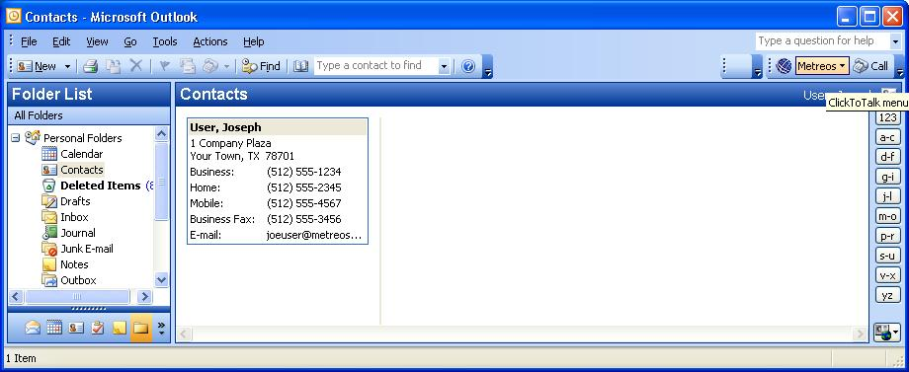

Before You Begin
Before installing the ClickToTalk Outlook plug-in, you or the administrator should ensure that:
- The Metreos runtime environment is running, and that the administrator has informed you of the IP address and port number ClickToTalk should use for connectivity.
- You or the administrator has registered a Metreos Application Suite account for you, and that you have the user name and password for this account at hand. Refer to the Metreos Application Suite Administration Guide for more information.
- You or the administrator has registered the IP phone which will be used to dial your ClickToTalk calls, as the primary device in your Metreos Application Suite account.
- You or the administrator has associated this same IP phone device with a Cisco CallManager user account. Refer to Cisco documentsfor more information.

Installing the Outlook Plug-In
You should first uninstall any existing Metreos ClickToTalk plug-in, by navigating to the Windows Start menu, Control Panel, Add or Remove Programs, and from there select the Metreos ClickToTalk plug-in for uninstallation, if indeed it had been previously installed.

Your Metreos Application Suite administrator will have provided you with the installation file for the ClickToTalk Outlook plug-in. The installation file will be named setup.exe, unless renamed by the administrator. Double-click on this file to begin installation, and follow the instructions on the ensuing wizard dialogs, accepting all defaults.

Once installation is complete, start Microsoft Outlook and the ClickToTalk button will be found on the Outlook toolbar, as shown in Figure 2.

Configuring the Outlook Plug-In
Before using ClickToTalk for the first time, you will configure ClickToTalk with the information required to log you into the Metreos Application Suite server, and to forward to you any call recordings you may request. This information will be saved in the registry, and as such, need be configured only after installation of ClickToTalk, or in the event that your logon information changes.

Clicking on the ClickToTalk button on the Outlook toolbar (see Figure 2), elicits a menu containing the single entry Settings. Selecting this menu item pops up a Metreos ClickToTalk Settings dialog as shown in Figure 3.

Figure 3: Outlook Client Settings
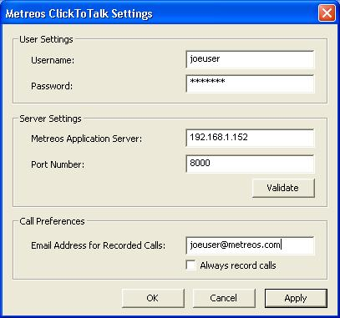

Username/Password
Enter your Metreos Application Suite user name and password, as supplied by the administrator.

Metreos Application Server/Port Number
Enter the Metreos Application Suite IP address, and port number, as supplied by the administrator.

Email Address for Recorded Calls/Always record calls
Enter the email address to which you wish to have sent any call recordings you might request. If you wish to record all calls you initiate, check the box labeled always record calls.

Verifying Connectivity
After entering information into the Metreos ClickToTalk Settings dialog, still Figure 3, press the button on this dialog labeled Validate, to ensure that connectivity to the Metreos Application Suite runtime environment can be established. A progress bar will be displayed, and you will be presented with a message indicating either that a connection was established, or the connection attempt failed. If successful, this one-time setup is complete, and Metreos ClickToTalk is ready to dial your calls with one click.

If connectivity was not established …
If, however, connectivity could not be established, ensure that:
- The Metreos runtime environment is active.
- You have entered into the Metreos ClickToTalk Settings dialog (Figure 3, above), the correct IP address and port number for the Metreos runtime environment.
- Your Metreos Application Suite user account has a password associated with it.
- You have entered into the Metreos ClickToTalk Settings dialog the correct account name and password for your Metreos Application Suite user account.

Making a Call
To make a call, simply select an entry in your contact list, and click the Call button (on the ClickToTalk Outlook toolbar, as shown in Figure 2 on page 13). The contact telephone number will be displayed to you at this time, which you can modify if you wish. Your IP phone will dial the selected party, so simply pick up the handset and talk.

Recording your call
At the time you click to talk, a dialog is displayed with the contact telephone number, as described above. To record the call, check the box labeled Record this call, found on this dialog. Of course, if in your ClickToTalk Settings, described earlier, you had specified that all calls were to be recorded, you need not specify that again here. To stop recording the call at any time, press the button labeled Stop Recording, also found on this dialog.

Conferencing
To begin a conference call, simply select multiple (up to four) entries from your contact list and click to talk. Should any party fail to answer, a message so indicating will appear on your phone display. Recording of your conference call is accomplished similarly to recording of a single party call as described above.

Metreos ActiveRelay

Metreos ActiveRelay™ enables the placing of calls to any individual using a single number, wherever that individual might be located. ActiveRelay bridges your cellular telephone (and/or any other external phones) to your office telephone and rings all phones, allowing you to choose which to answer. Once connected, the call can easily be transferred to other devices known to the Metreos Application Suite. To the caller, the call sounds like a normal call, and does not exhibit the multiple ring sequences common to older style phone applications in this genre.

Active Relay Features
- One-number portability – Your contacts can reach you at a single number.
- Multiple endpoints – Your contact’s call can ring any number of phones.
- Keep on talking – Begin talking on your cell and seamlessly switch to your office phone.
- Standard independent – TDMA, CDMA, GSM are supported.
- Caller ID push – Calling number is forwarded to any phone so equipped.

Before You Begin
Before Metreos ActiveRelay can be used for the first time, the administrator must have configured the Metreos Application Suite and Cisco CallManager appropriately.

Specifically, if you are to be the recipient of calls relayed via ActiveRelay, your primary (desk) telephone must be registered as such with the Application Suite, as well as the numbers of any external phones to which you wish your calls to be relayed. See the Metreos Application Suite Administration Guide, Edit User Account, for details.

Using ActiveRelay
When a caller dials the number of your primary device (telephone), as registered with the Application Suite, your primary phone will ring. After a brief delay all other phones, configured as external numbers, will ring.

Transferring a Call
Once you have answered the call on any phone, you may transfer the call to any of your configured IP phones. Select Active Relay from this phone’s Services menu. A Swap key will now be visible on the phone display. Press Swap, and a series of beeps will be heard on the original phone, indicating that the call swap request is pending. Press the original phone’s pound key twice (##) to confirm the transfer.

If your account is not associated (within Application Suite configuration) with the phone to which you are transferring the call, the phone will prompt for your account user name and password, before the swap option will be available to you.

If, additionally, this phone is not registered as a device with the Application Suite, you will be prompted, via the phone menu, for the number of this phone.

Metreos ScheduledConference
Metreos ScheduledConference™ is a Web-scheduled dial-in and dial-out conferencing system. With ScheduledConference you can schedule and participate in conferences calls with a few mouse clicks.

Scheduling a Conference
To schedule a conference, sign into the Application Suite Administration Console, as described in Logging In on page 8, and select Metreos ScheduledConference from the main page. You will be presented with the ScheduledConference page. From here click the button labeled Add Conference. The Schedule New Conference page will appear, as shown in Figure 4.

Enter your Metreos Application Suite user name, select the date and time at which the conference will begin, enter the expected conference duration, and the expected number of participants. Click Create Conference, and your conference call is now scheduled.

Figure 4: Schedule New Conference
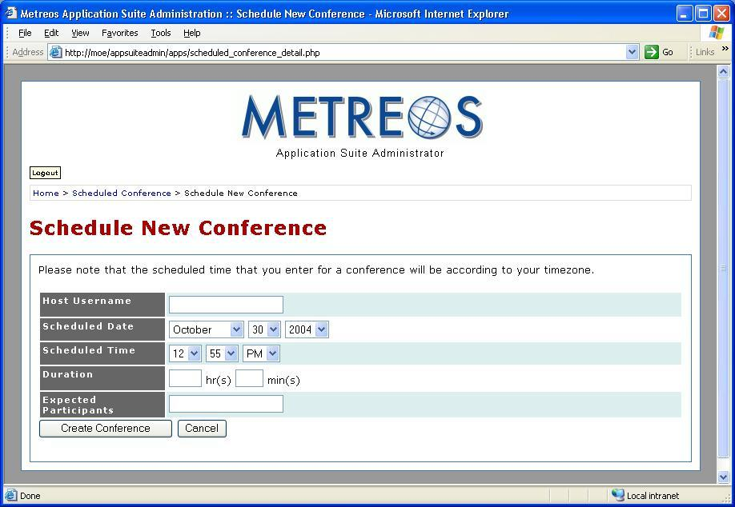

Dialing Into a Scheduled Conference

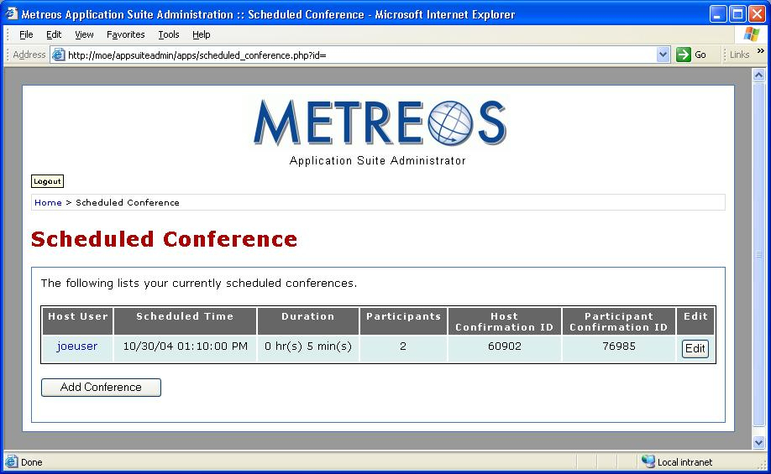
Figure 5: Scheduled Conference

You will dial into a conference using the Metreos ScheduledConference extension as configured by the administrator. Dial this extension, and the ScheduledConference attendant will ask you to enter your conference PIN, followed by the pound key.

As illustrated in Figure 5, associated with your scheduled conference are two access numbers for the conference, which are:
- Host PIN
- Participant PIN

If you scheduled the conference, key in the host PIN at the prompt. If you are an invited participant, you will instead enter the participant PIN. The attendant will welcome you to the conference. As each subsequent party dials in, the attendant will announce his or her arrival.

Making Changes to a Scheduled Conference
You may change a conference scheduled date, time, and number of participants at any time prior to conference expiration. Click the button labeled Edit on the Scheduled Conference page, as shown above, and the Edit Conference page is presented. From here make any desired changes and press the button labeled Update Conference.

Metreos Intercom

Metreos Intercom™ permits instant communication over IP phones without the need to dial a number. Lifting the handset, a user selects from a menu the parties to whom they wish to communicate, and audio connectivity is instantly established. Metreos Intercom can be configured to act as a group paging system for the broadcast of voice messages or pages, in the manner of a traditional paging system.

Metreos Intercom uses the concept of an intercom group. To broadcast a Metreos Intercom message, you select an intercom group to which you wish to talk, and your message will be broadcast to the IP phone speaker of each member of the group. Intercom groups are created by the administrator. If the administrator has defined the group to be public, anyone can join or leave the group once it has been created. If the group is private, its membership is determined solely by the administrator.

Before You Begin
Before you can broadcast a message over Metreos Intercom, the administrator must first have ensured that:
- The Metreos runtime environment is active.
- The Metreos Intercom IP Phone Service is installed on CallManager.
- Your IP phone is subscribed to the Metreos Intercom IP Phone Service.
- An intercom group exists to which you belong, or to which you can join.

See the Metreos Application Suite Administration Guide for further information.

Initiating an Intercom Broadcast
To broadcast to a group:
- Press the Services button on your IP phone.
- Select Metreos Intercom from the phone’s Services menu.
- Select the intercom group to which you wish to broadcast.
- Begin talking. Your voice message is heard on the phone speaker of each group member.
- When done, press the Exit button.

Receiving an Intercom Broadcast
When someone broadcasts a voice message to an intercom group to which you belong, you will hear the message on your phone’s speaker. If the administrator has enabled the talkback feature for this intercom group, a Reply button will be active on your phone display. When you wish to speak to the group, press the Reply button and speak normally, without lifting the handset.

Metreos RapidRecord

Metreos RapidRecord™ automatically records calls placed to and from a configured group of telephones, permitting seamless, hands-off call recording. Calls so recorded may be played back either from a Web interface, or directly from the IP phone that placed or received the call. Since all calls are recorded, businesses can avoid a problem common to other applications of which the reader may be aware, that of missing call content occurring prior to the time recording could be enabled.

Enabling Recording of Calls
The administrator enables or disables recording of calls per Metreos Application Suite user account. The User Account Configuration page, as described in the Account Management section of the Metreos Application Suite Administration Guide, contains check boxes for two items related to Metreos RapidRecord:
- Record Calls
- Recordings Visible

When Record Calls is enabled on a user account, each call in which the user participates is recorded. When Recordings Visible is enabled on the account, a button is enabled on the participant’s phone to stop and restart recording at any time. This feature is described in detail in the next section.

Stop and Restart Recording
When a user account is configured as described above, a Stop button appears on the participant’s phone as a call is being recorded. When the participant presses Stop, recording is of the call is interrupted, and the Stop button becomes a Start button. If the participant subsequently presses Start, recording resumes and the intervening gap in the recording is recovered. If instead, the participant does not restart recording, the conversation subsequent to his or her pressing Stop is discarded.

Listening to Recorded Calls
To listen to call recordings, the administrator will selects Metreos RapidRecord from the Application Suite Administration Console main page.

Application Notes
Note that Metreos RapidRecord could possibly elicit unexpected results when Metreos ActiveRelay is also configured for a user for whose call is to be recorded.

This guide assumes that all documented announcements are enabled at your installation. If you do not hear a particular announcement, simply skip forward in this document to the description of the announcement you are currently hearing.
By default you cannot begin a conference more than 15 minutes in advance of the scheduled start time. This threshold can however be modified by the administrator. You also cannot begin a conference at any time after the conference is scheduled to end.

